**Change request log**

**Team**

Chris Zeller  
Kristina Kepic

**Change Request**

jEdit change request #4 - Add a clear recent directories button in the context menu

**Concept Location**

Time spent: 60 minutes

| We ran the system using ant |  |
| --- | --- |
| We interacted with the context bar and found recent directories in Utilities/Recent Directories/ | Identify the feature in question and some properties as well as find searchable text |
| We used jEdit’s search in directory feature to query “Recent Directories” | Find out where the text is located and where the class might be instantiated |
| We found 13 results |  |
| We looked in the english localization and found that the localization key is recent-directories.label | Look up the key and find out what elements reference the localization key |
| We looked in the gui props file (the only non localization file) and found “recent-directories.code = new RecentDirectoriesProvider();” | Check all results and especially all unique results |
| We used jEdit’s search in directory feature to query “recent-directories” since it is a key that needs to be traced back |  |
| We looked in the gui props file again and found “utils=vfs.browser \ %recent-directories \ - \ %favorites \ %current-directory \ …”, which is the layout of the utilities menu which is to be modified. However this file will not be modified since we can conclude from the .code tag from the previous result that RecentDirectoriesProvider is the class to be modified |  |
| We did determined that the localization files would need to be modified as well (only english since that is the only language we know and are qualified to create) because we are introducing a new feature that will have text on it and similar features use it as well |  |
| We used the search everywhere IDE feature to find the “RecentDirectoriesProvider” class | Find out where the menu is made and follow the code back to where adding a menu option is applicable |
| There was 1 result, the RecentDirectoriesProvider class in org/jgt.sp/jedit/menu/RecentDirectoriesProvider.java |  |
| We looked through the class and found that the RecentDirectoryProvider creates all the menu items for recent directories so this is definitely the class to edit |  |

**Impact Analysis**

Time spent: 30 minutes

| We remember that the english localization needs to be modified to account for accompanying class changes | The text must be localized just like the rest of the app |
| --- | --- |
| We inspected the update function in RecentDirectoryProvider (the main function) and found the following classes to follow up on: HistoryModel, JMenu, and JMenuItem |  |
| HistoryModel gets the recent files | Look for some way to reset the model |
| JMenu and JMenuItem are removed from the set | Both are used to create the menu structure and the accompanying functionality so the instance will be modified but not the class |
| HistoryModel is removed from the set | HistoryModel must be able to remove all items and this is possible in the current implementation using the removeAllElements() method |
| The set consists of the english localization and the RecentDirectoryProvider class | These are the only two files impacted |

**Actualization**

Time spent: 60 minutes

| We added the creation of a new JMenuItem at the end of the sorting process in RecentDirectoriesProvider | The new JMenuItem is needed to create the button for the new feature |
| --- | --- |
| We added an action listener to the new JMenuItem so that when it is interacted with the proper action occurs | A new action listener is needed since the clear recent directories has a different function than the rest of the other menu items |
| We added a separator to the menu and then added the new menu item | A separator is not needed but is helpful for determining that this is a separate feature. This is the same way clear recent files is separated |
| We added the localization clear-recent-dirs.label for english “Clear Recent Directories” | The localization is needed so that the reference to the language is matched |
| We added a class MenuUtilitiesTest for proper organization of test code | The new class is needed for proper organization of the unit tests |
| We added a unit test for the regular and the only expected behavior | The unit test is not needed but is important for receiving a good grade on this assignment |
| The test adds elements to the list and removes them | It is meant to test the removeAllElements behavior which the clear recent directories feature relies on |

**Validation**

Time spent: 15 minutes

| Test cases defined: Remove elements functions  Inputs: 3 x addItem(), removeAllElements()  Expected outputs: getSize() = 3, getSize() = 0 | This is the regular and only expected behavior  The test passed |
| --- | --- |

**Timing**

Summarize the time spent on each phase.

| **Phase Name** | **Time (in minutes)** |
| --- | --- |
| Concept location | 60 mins |
| Impact Analysis | 30 mins |
| Actualization | 60 mins |
| Verification | 5 mins |
| **Total** | 155 mins |

**Reverse engineering**

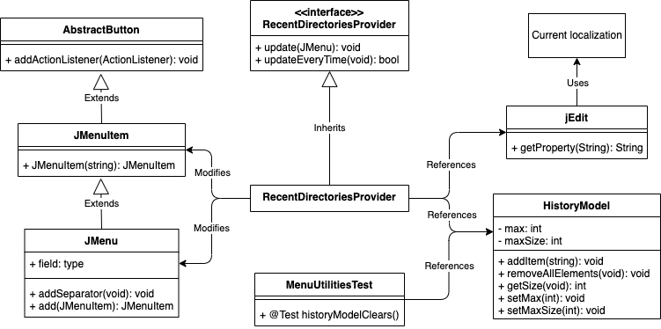

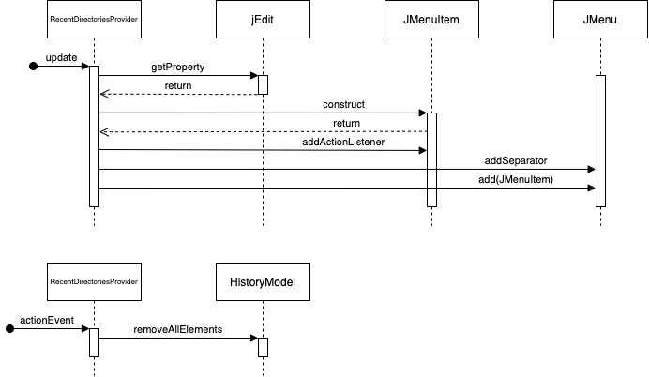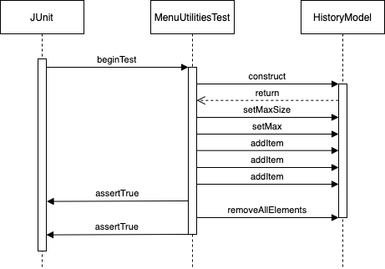

**Conclusions**

For this change the concept location was a little hard, the localization layer was difficult to get through but it did yield the intended results since it pointed directly to the concept location. Concept location, impact analysis, and actualization was all done manually in the pair programming process and helped with keeping on track and finding the best way to proceed forward. Testing was performed using JUnit which is the unit testing utility used on the jEdit project. We had a few problems getting the HistoryModel to work but the issue was determined successfully

Classes and methods changed

* org/gjt/sp/jedit/menu/RecentDirectoriesProvider.java
  + RecentDirectoriesProvider.update()
* org/jedit/localization/jedit_en.props
  + clear-recent-dirs.label
* test/org/gjt/sp/jedit/menu/MenuUtilitiesTest.java
  + @Test MenuUtilitiesTest.historyModelClears